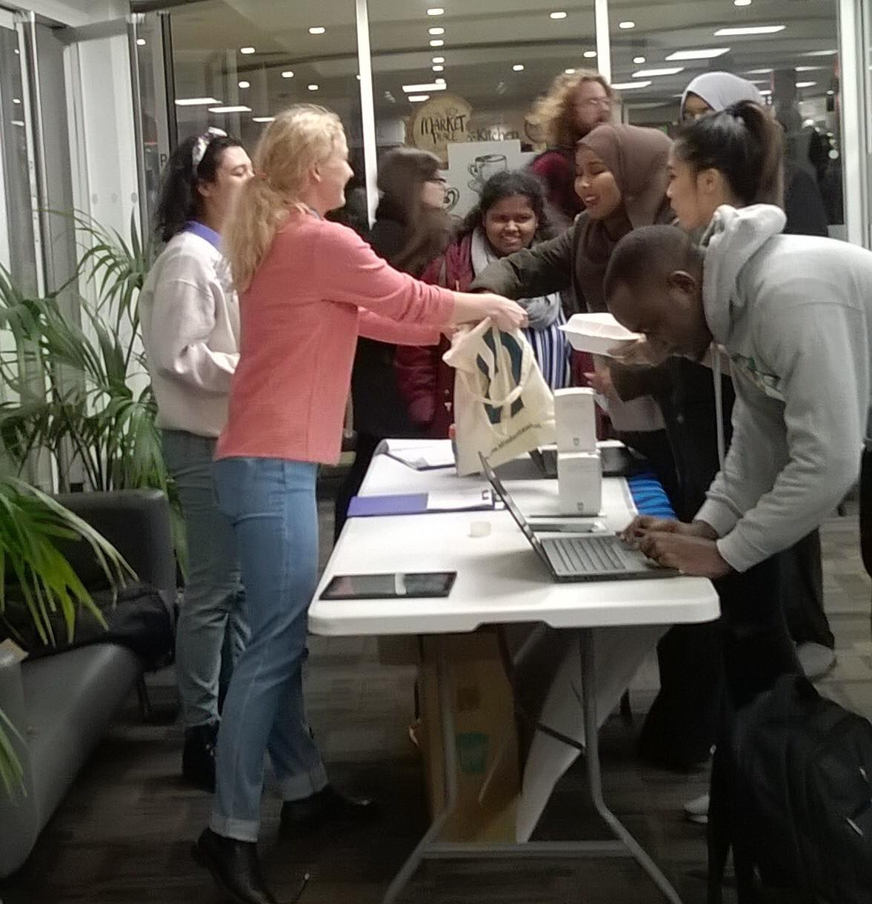
Coffee Cup Survey event report

Introduction

On 24th January from 1:00PM until 4:00PM the green connectors ran an event in the Kingston University Penrhyn Road reception. The aim of this event was to collect data about the recycling habits and knowledge of the students and staff of Kingston University. The goal was to speak to as many students as possible in order to create discussions about recycling amongst students through the issue of disposable coffee cup waste.
The survey

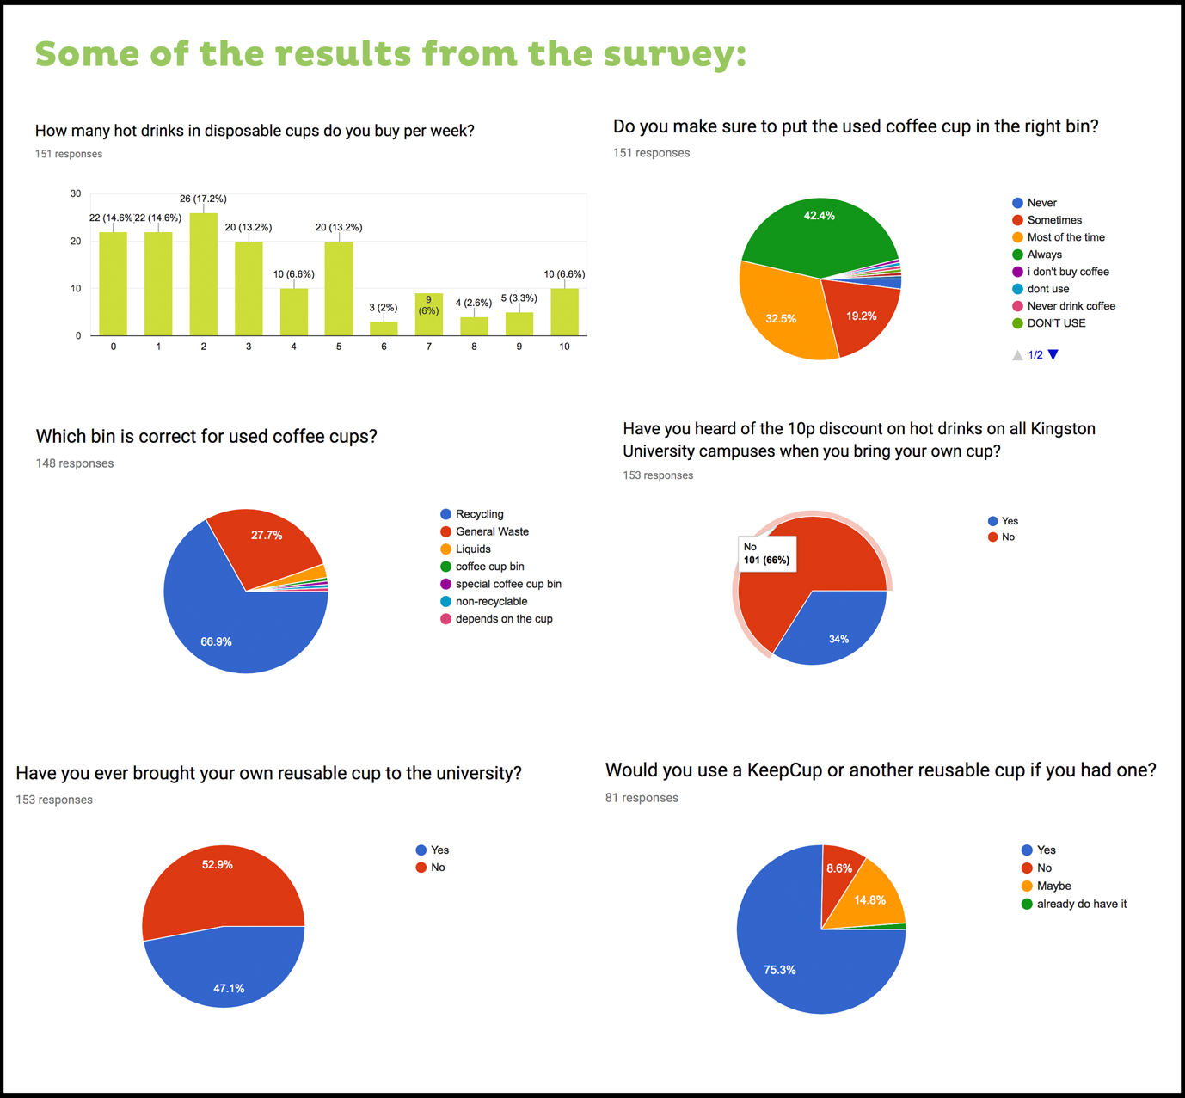

Questions & Answers Analysis

- How many hot drinks in disposable cups do you buy per week?
(151 responses)
22 people (14%) said that they do not purchase any hot drinks in disposable cups, whereas 10 (6,6%) people stated that they buy 10 or more per week. Most of the students and staff (64,8%) who answered this question said that they usually buy between 1-5 hot drinks in disposable cups per week.

- Do you make sure to put the used coffee cup in the right bin?
(151 responses)
42,4% said that they make sure to always put the coffee cup in the right bin and 32,5% said they do it most of the time. Only 3 students (2%) said that they never put the coffee cup in the right bin.

- Which bin is correct for used coffee cups?
(148 responses)
A great majority of 99 Students (66,9%) said that they put their coffee cup in the recycling bin. 41 students (27,7%) stated that they think the used coffee cup should go in the general waste bin.

- Have you heard of the 10p discount on hot drinks on all Kingston University campuses when you bring your own cup?
(153 responses)
Only 52 students (34%) said that they have heard about the discount, however, 101 students and staff (66%) said that they have never heard of it.

- Have you ever brought your own reusable cup to the university?
(153 responses)
72 (47,1) students answered that they have brought their cup and 81 (52,9) stated that they have never brought their own reusable cup to the university.

- Why have you never brought your own cup to the university?
(64 responses)
A lot of students stated that the reason they have never brought their own cup is that they never realised it as an option. Many students also do not have a reusable cup which they could take with them to university. There is a lot of statements about the inconvenience of having to carry it with them because it is heavy and takes up a lot of space in the bag. A few people also state that they are not organised and it requires extra effort, which means they forget to do it.

- Would you use a KeepCup or another reusable cup if you had one?
(81 responses)
61 students (75,3%) said that they would use a KeepCup if they had one. 12 (14,8) answered ‘maybe’ and only 7 (8,6%) answered ‘no’.

- What kind of reusable cup do you usually bring to university?
(133 responses)
66 students (49,6%) answered that they bring a regular mug to the university and 39 students (29,3%) said that they bring a KeepCup. Some of the other answers included: thermos, flask, a reusable cup from another brand.

The results
All together 154 students and staff took part in this survey and we managed to collect ? K-numbers.

