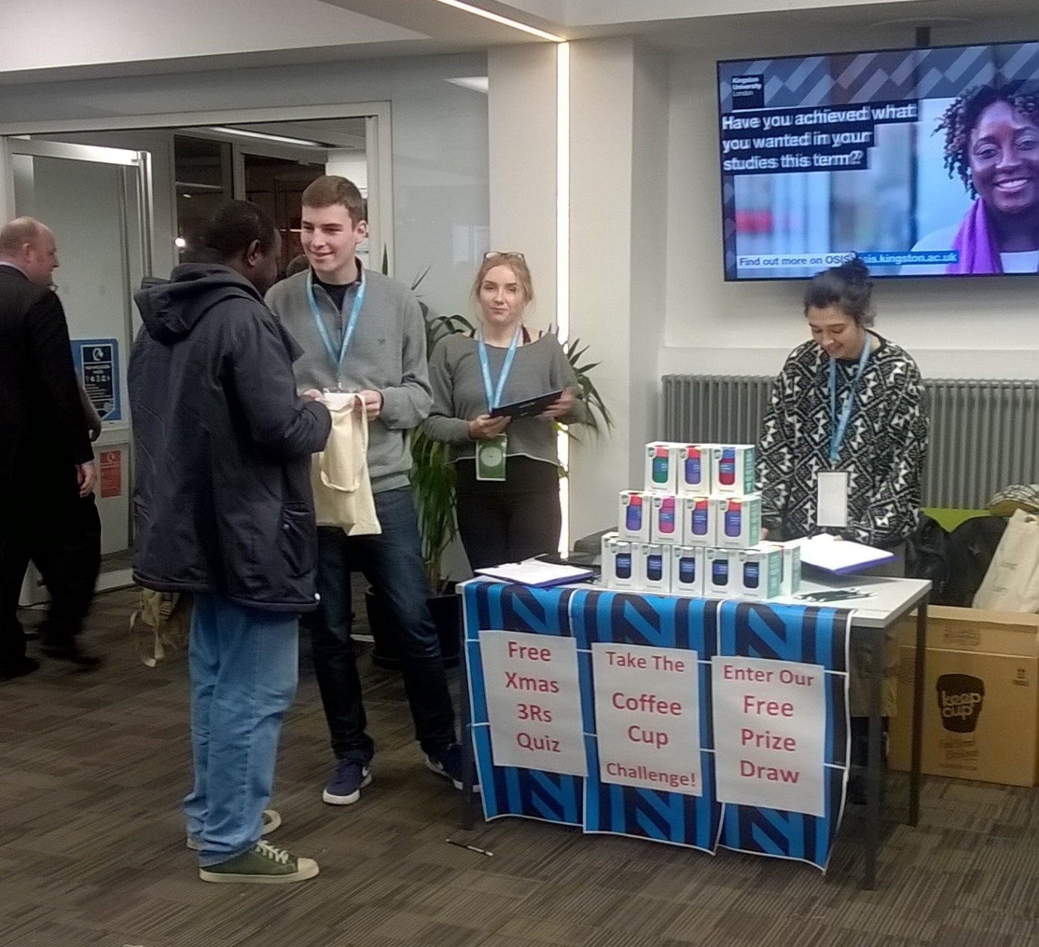

Coffee Cup Quiz event report

Introduction
On the 13th December 2017 the green connectors ran a three-hour-event in the reception of Kingston University Penrhyn road campus. The aim of this event was to engage with as many students as possible in order to learn about their recycling knowledge and habits. The green connectors carried out an interactive quiz, which was created to test the recycling knowledge of Kingston University’s students and staff, through the issue of disposable coffee cups. In order to engage students in this topic, a prize draw for winning a KeepCup was included at the end of the quiz.

The quiz

The quiz was created on BuzzFeed platform and consisted of 4 multiple choice questions. (Available at: https://bzfd.it/2G77E5s)
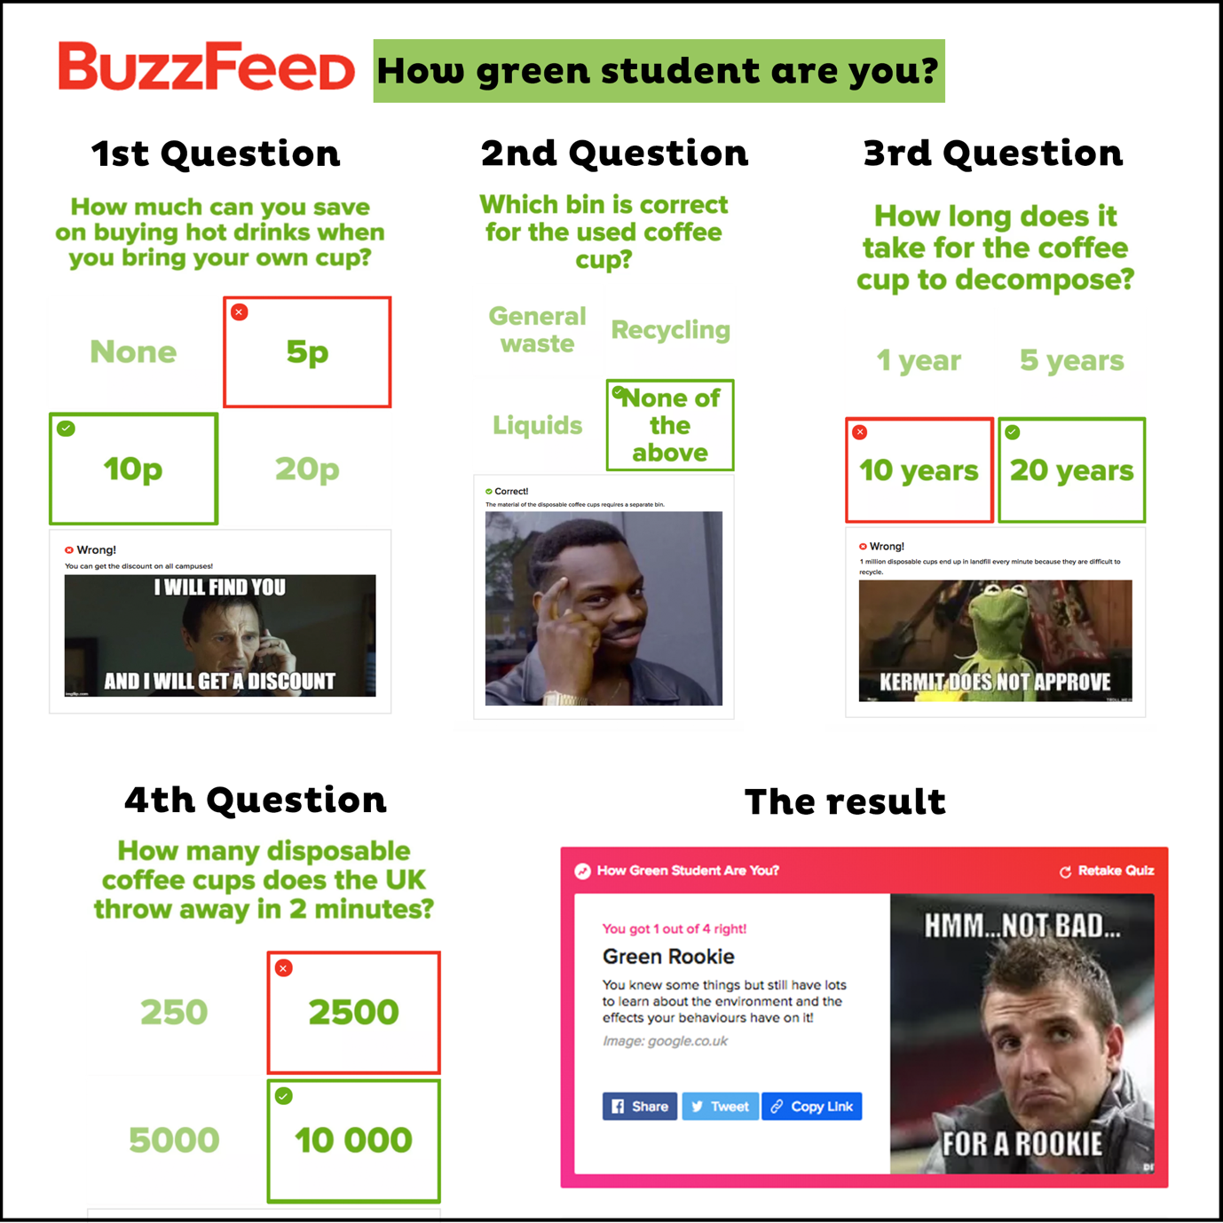

How well did students do?

There was only one student who answered all the questions right. Most students got 2 correct answers out of 4. There was only a couple of 3 out of 4-s. Many students also got 0 out of 4 and 1 out of 4. The question that students mostly struggled on was ‘’Which bin is correct for the used coffee cup?’’. Most students answered recycling bin, however the correct answer was none of the above. Many students did not know that there was a discount offered in all the campuses when you bring your own cup. There was a lot of surprise when the students realised how many years it takes for the coffee cup to be decomposed and also how many coffee cups the UK throws away in 2 minutes.

The results
All together 100 students completed the quiz and we managed to collect 97 K-numbers.

